**3 Days Maasai Mara Safari**

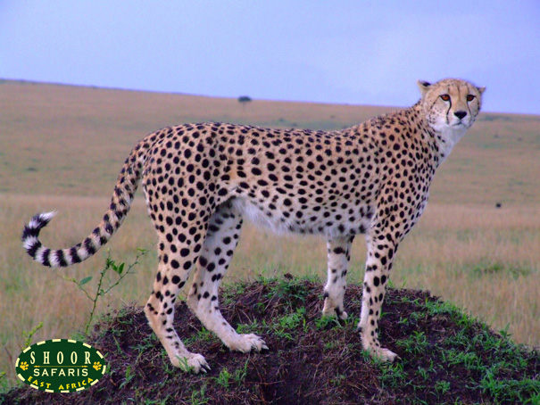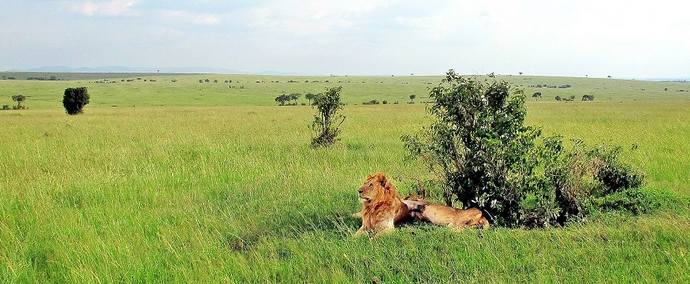

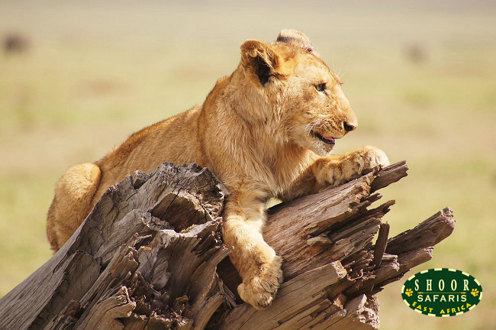

**Day 1**  
Start of your Safari!  
Our Driver-Guide reports to your hotel for Start of the safari, with an 8.00am departure for a scenic drive down into the Great Rift Valley, onwards to Maasai Mara, Kenya's premier game reserve. (Drive time 5.5 hours). You will be in your own private safari vehicle. Stop briefly enroute at the Great Rift Valley viewpoint to enjoy the stunning views of what is the world's largest Valley, said to be even visible from space. Arrive at Maasai Mara for lunch. The afternoon game drive at 3.30pm allows spotting of the magnificent wildlife in the park ranging from the Big Cats such as Lion, Leopard & Cheetah to Rhino, Elephant and Wildebeest. Return to your lodge by 6.30pm. Dinner and overnight at Mara Sopa Lodge or Mara Leisure Tented Camp or similar.

**Day 2**  
Enjoy a Full day in Maasai Mara.  
You will be taken on two game drives today, one in the morning from 6.15am to 9am, before breakfast and the other in the late afternoon after lunch from 3.30pm to 6.30pm. As your safari is private your game drive timings are flexible, useful if you are travelling with children, or are on a honeymoon. You may also choose to have a full day game drive [one for the whole day] with a packed picnic lunch at no extra cost. Return in the evening for dinner and overnight at the lodge. Dinner and overnight at Mara Sopa Lodge or Mara Leisure Tented Camp or similar.

**Day 3**  
At the break of dawn you embark on your concluding game drive in the Mara followed by a relaxed breakfast and onward departure for Nairobi. Arrive Nairobi by early afternoon [typically by 2.30pm] . Drop off at your hotel, or free onward transfer to the airport for your flight home. You may also see a more general Safari itinerary here [Maasai Mara Safari](https://www.masaimara.travel/safari-packages.php) with more options of camps and lodges in Maasai Mara during the 3 day Safari.

**Accomodation during the Safari**

Day 1 : [*Mara Sopa Lodge*](http://www.sopalodges.com/masai-mara-sopa-lodge/overview), *[Maasai Mara Game Reserve](http://www.shoortravel.com/masaimara.html)*

Day 2 : [*Mara Sopa Lodge*](http://www.sopalodges.com/masai-mara-sopa-lodge/overview), *[Maasai Mara Game Reserve](http://www.shoortravel.com/masaimara.html)*

Day 3 : Leisurely drive back to [*Nairobi*](http://www.shoortravel.com/nairobi.html)

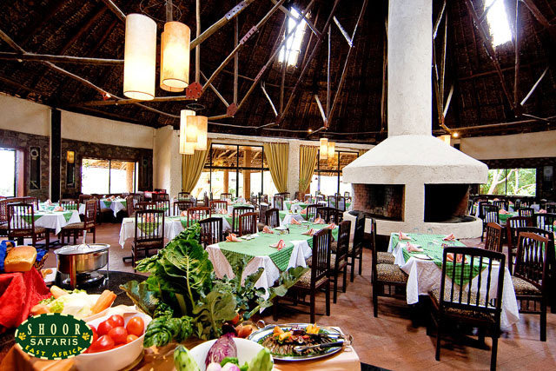

**PRICE & DATES**

**Rates are per person sharing in US Dollars.  
Rates depend on number of people travelling together in one vehicle hence 2 [two people], 4 and 6 persons.**

|  |  |  |  |
| --- | --- | --- | --- |
| **Travel Dates** | **Per Person Sharing (US $)** | | |
| Number of People Travelling >>> | 2-3 persons | 4-5 persons | 6 persons |
| 04 Jan - 31 Mar 2020 | 695 | 575 | 520 |
| 01 Apr - 30 June 2020 | 610 | 490 | 450 |
| 01 July - 31 Oct 2020 | 775 | 660 | 600 |
| 01 Nov - 21 Dec 2020 | 650 | 530 | 490 |
| 22 Dec - 03 Jan 2020 | 790 | 690 | 635 |

Top of Form

ENQUIRE ABOUT THIS SAFARI

Bottom of Form

**Tour Price Includes:**  
- Accommodation as specified in the itinerary on Full board* basis in the lodges.  
- Exclusive transport in a Safari Tour Microbus with a Game viewing roof hatch and UHF radio.  
- 04 Private Safari game drives for the tour.  
- Services of a certified Professional, English-speaking Driver Guide including all his expenses & allowances.  
- Fuel, driver and car park fees, driver's allowance.  
- All Park entry fees for clients, driver guide and vehicle.  
- 24 hour Back Up support if required.

*\* Full Board basis includes 3 meals per full day starting with Lunch, ending with Breakfast.*

**Tour Price Excludes:**  
- International flight tickets and visa costs.  
- Tips, drinks, laundry, calls, and all such costs of a personal nature.  
- Credit Card Surcharge of 5 to 7% will apply or Bank Transfer Fees of USD 50.